Name: ____________________________________________________________________

AP World Review: Modern: Video #3: Unit #1, Topic 1.3

**Hinduism**

* Hinduism is a **________________________________________** belief system:
  + Everything is created by one being
* No single founder
* Key Texts:
  + _____________________________ - written in Sanskrit
    - Upanishads - found in the Vedas
  + Bhagavad Gita - stressed doing ____________________________
* Core Beliefs:
  + Multiple manifestations of ____________________________
    - One true god, takes on many forms - present in every person
  + __________________________________:
    - One’s duty or the way of living
    - Doing good dharma will help end the cycle of rebirth
  + Karma:
    - Helps determine one’s __________________
  + Reincarnation
    - People are reborn in the next life until one is freed
  + Moksha:
    - Ultimate _______________ in Hinduism
    - Ends the cycle of _____________________

**The Hindu Caste System**

* Brahmins:
  + ________________________ caste
* Kshatriyas:
  + ________________________ class
* Vaishyas:
  + Merchants and artisans
* Shudras:
  + Peasants and serfs
* Dalits:
  + ________________________________________________________________
* Jatis:
  + _________________________ that have developed over time
* India banned ______________________________________ based on castes

**Drawing of the Hindu Caste System**

**Buddhism**

* Founded by Buddha (Siddhartha Gautama)
* Was a ________________________________ to Vedic beliefs
  + Buddha rejected the religious authority of Brahmins
  + Not focused on the existence of God
  + Challenged the Hindu _______________________________________
    - Anyone could achieve _______________________________
* Core Beliefs:
  + Karma - influences rebirth
  + Reincarnation
  + _____________________________________
  + ________________________ - one could achieve Enlightenment

**4 Noble Truths And The Eightfold Path**

* 4 Noble Truths:
  + ____________________________________ in life
  + Suffering comes from selfish desire
  + Ending suffering will achieve ______________________________
  + Follow the Eightfold Path
* Noble Eightfold Path
  + Right View, Right resolve, right speech, right conduct, right livelihood, right effort, right mindfulness, right samadhi - meditative consciousness

**Buddhism**

* Over time, it branched into many schools:
  + Mahayana (India):
    - _______________________________ - people who delayed entrance into Nirvana to help others
* It spread throughout Asia
  + Under the leadership of Mauryan leader __________________
  + Missionaries and merchants
    - Similar to ____________________________________________
  + Educational institutions:
    - Promoted Buddhism’s teachings
* Some Buddhists practiced a ____________________________________ life
  + Similar to ____________________________________________________

**South And Southeast Asia Kingdoms**

* Srivijaya:
  + Powerful state in Southeast Asia
  + Powerful _________________________, controlled commerce
  + Kings were committed to Buddhism
    - Built Buddhist ___________________________________
* Khmer Empire:
  + Influenced by both Hinduism and Buddhism
    - Added Buddhist temples in the ___________ century

**Quick Recap**

* Hinduism:
  + Key texts
  + Dharma, Karma, Reincarnation
  + ________________________________________________________________
* Buddhism:
  + Reaction to Hinduism
  + Eightfold Path
  + Meditation
  + Nirvana
  + __________________________ through Asia and how it changed
  + Monastic life for some (Like Christianity)

Part II

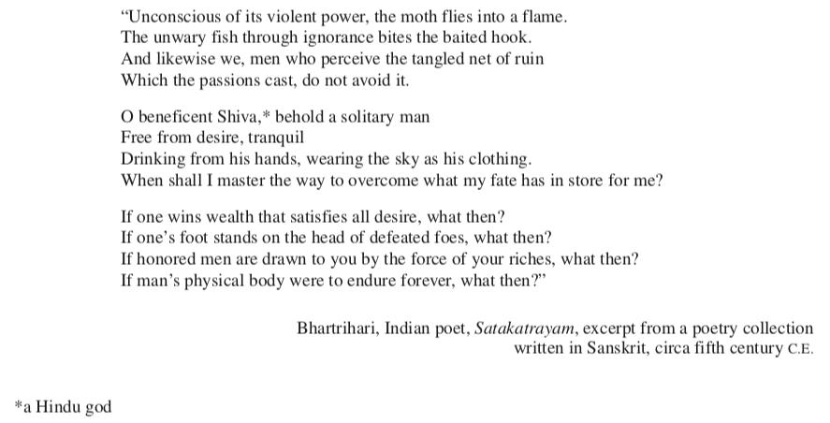

1. What is the stance of materialism according to this poem? How do you know? _____________________________________________________________________ _________________________________________________________________________________________________________________________________________________________________

2. What other religion/belief system are these ideas most similar to? __________________________________________________________________________________